**9 SCIENCE EARTH AND SPACE SCIENCE ASSIGNMENT**

Earthquake proof buildings

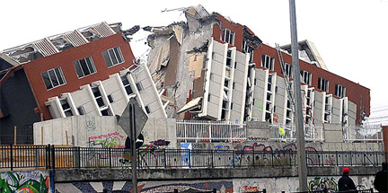

Name:______________________ Teacher:_______________________

Form:______________________ Due date:______________________

**Aim:** This assignment will allow you to see how the design and construction of buildings in earthquake prone areas allows them to withstand the movements.

**1. Take home this assignment for one night and complete as much as you like.**

**2. The next day back at school you will complete the rest of the assignment with a laptop/personal device and hand it in at the rest of the lesson.**

⬩ The in-class completion of the assignment is to be done under test conditions.

⬩ Write the answers in your own words, do not copy and paste directly from any source.

**Introduction:**

⬩ Earthquakes alone don't kill people; collapsed buildings do. In Chile, an 8.8 magnitude earthquake in March 2010 killed more than 700 people. On January 12, 2010 a less powerful earthquake, one measuring 7.0 magnitude, killed more than 200,000 in Haiti.

⬩ The difference in those death tolls comes from building construction and technology. In Haiti, buildings were constructed quickly and cheaply. Chile, a richer and more industrialized nation, adheres to more stringent (strict) building codes.

**Ways to make buildings earthquake-proof**

Making buildings stronger

This can be done by using materials that are strong yet flexible. Also by putting the materials together in such a way that the buildings framework and structure is strong but also flexible.

|  |  |
| --- | --- |
| Before earthquake | During earthquake |
| https://mceer.buffalo.edu/infoservice/images/ReferenceSources/as1.gif | https://mceer.buffalo.edu/infoservice/images/ReferenceSources/as3.gif |

Base Isolation

By making buildings more flexible, so they sway and slide above the shaking ground rather than crumbling.

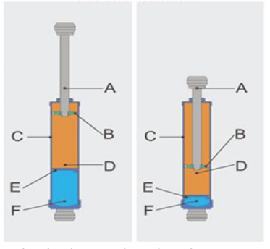Engineers have constructed skyscrapers that float on systems of ball bearings, springs and padded cylinders. They don't sit directly on the ground, so skyscrapers are protected from some earthquake shocks. In the event of a major earthquake, they sway up to a few feet. These buildings also have a space left around them so that if they sway they do not crash into other buildings.

Dampers

These help slow down the movement of the building once the earthquake hits. Some of dampers are like pistons that slow the wave like motion of the building down. Other dampers work by having large masses (called tuned mass dampers) that move in the opposite direction to the earthquake movement, slowing the movement down.

Questions

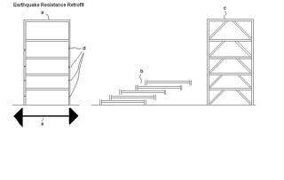1. Look at the diagrams on the right.  **State** what the building frame on the (2 marks) right has that makes it more earthquake-proof than the building frame on the left.

**Explain** why this feature makes the building structure more earthquake-proof

________________________________________________________________________________________

________________________________________________________________________________________

________________________________________________________________________________________

________________________________________________________________________________________

________________________________________________________________________________________

________________________________________________________________________________________

________________________________________________________________________________________

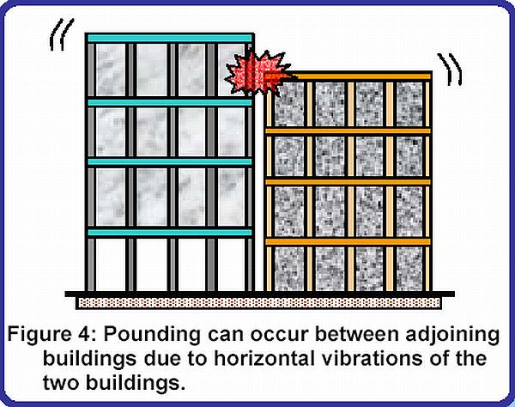2. Look at the diagram on the right. (3 marks)

**Describe** three design problems with the buildings shown.

________________________________________________________________________________________

________________________________________________________________________________________

________________________________________________________________________________________

________________________________________________________________________________________

________________________________________________________________________________________

________________________________________________________________________________________

________________________________________________________________________________________

________________________________________________________________________________________

________________________________________________________________________________________

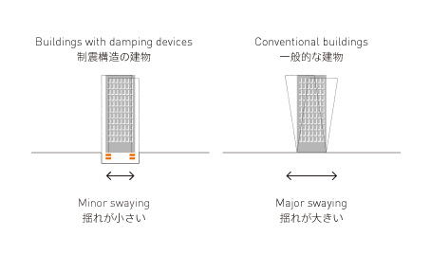3. Look at the diagram on the right. (3 marks)

a. **State** the feature that helps to earthquake-proof the building.

________________________________________________

b. **Describe** two advantages of this feature.

________________________________________________________________________________________

________________________________________________________________________________________

________________________________________________________________________________________

________________________________________________________________________________________

________________________________________________________________________________________

________________________________________________________________________________________

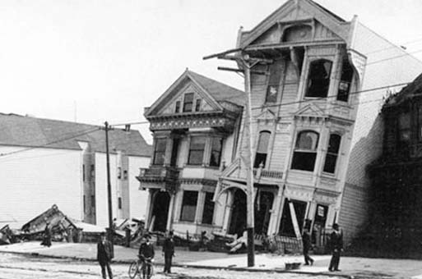4. Look at the photograph of the houses on the right. (3 marks)

This house was damaged by an earthquake in San Francisco, U.S.A.

**Describe** three reasons as to why you think the houses were was so badly damaged.

________________________________________________________________________________________

________________________________________________________________________________________

________________________________________________________________________________________

________________________________________________________________________________________

________________________________________________________________________________________

________________________________________________________________________________________

________________________________________________________________________________________

________________________________________________________________________________________

________________________________________________________________________________________

________________________________________________________________________________________

________________________________________________________________________________________

________________________________________________________________________________________

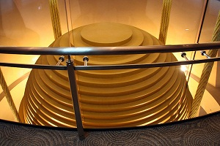5. This is the Taipei Tower in Taiwan. It is 508m tall. Designing a building this large presented unique challenges because Taiwan is subject to typhoons and earthquakes.

To counter movement, an 800-metric tonne, spherical steel ball is located in the building.

a. **State** the name given to this earthquake-proofing method. (1 mark)

________________________________________________________________________________________

b. **State** the floor level of the building that the spherical steel ball is located. (1 mark)

_________________________________________

c. **Explain** how the large steel ball helps to reduce movements in the building caused by earthquakes.

(2 marks)

________________________________________________________________________________________

________________________________________________________________________________________

________________________________________________________________________________________

________________________________________________________________________________________

________________________________________________________________________________________

________________________________________________________________________________________

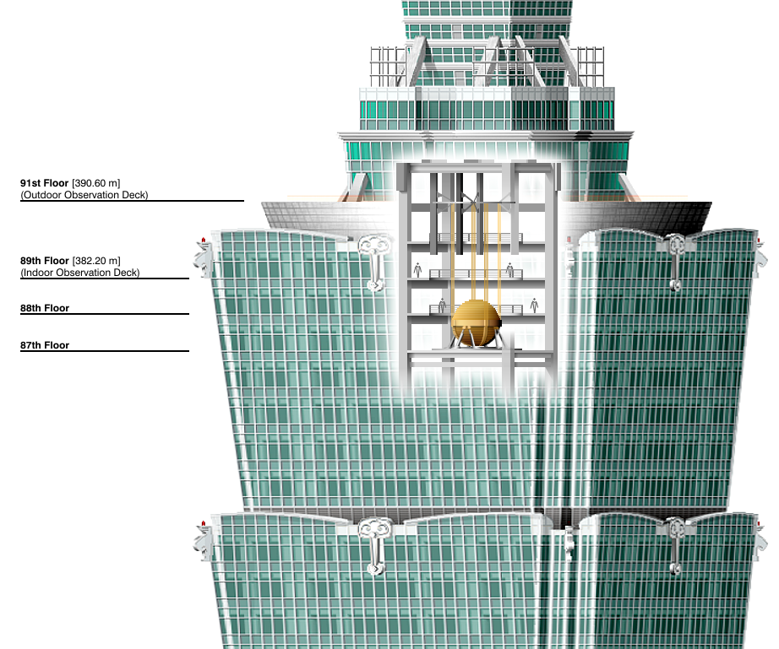

5. Answer the following questions using the diagram and information below.

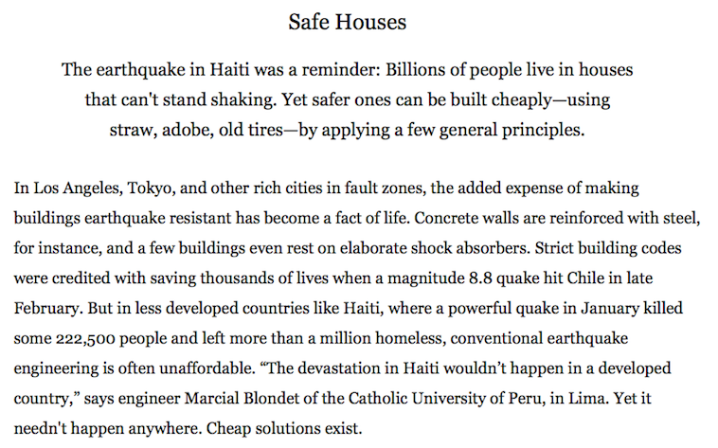Visit the webpage: <http://ngm.nationalgeographic.com/big-idea/10/earthquakes> to see the below image in colour.

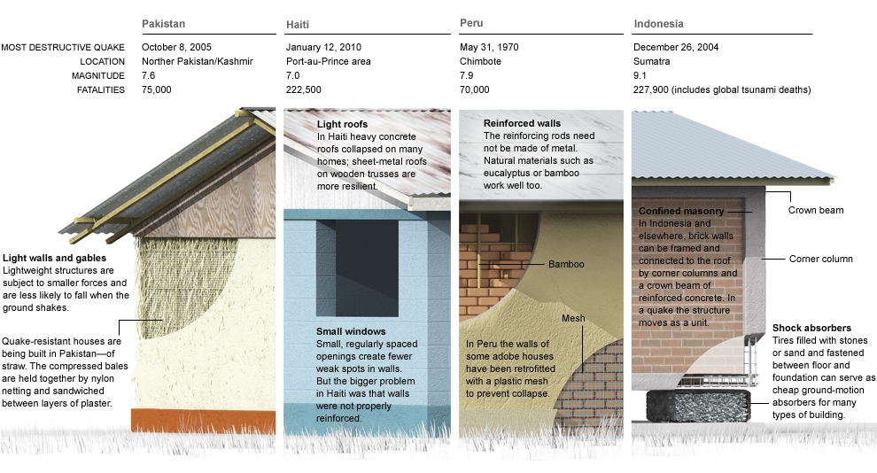

a. **State** which earthquake caused the greatest number of fatalities. (1 mark)

________________________________________________________________________________________

b. **Describe** two examples of cheap ways that buildings can be isolated from the base (ground). (2 marks)

________________________________________________________________________________________

________________________________________________________________________________________

________________________________________________________________________________________

________________________________________________________________________________________

________________________________________________________________________________________

c. **Explain** why buildings in earthquake prone areas are safer if they have small windows. (2 marks)

________________________________________________________________________________________

________________________________________________________________________________________

________________________________________________________________________________________

________________________________________________________________________________________

d. **Explain** why the devastation following the earthquake in Haiti would not have been as severe in a developed country. (2 marks)

________________________________________________________________________________________

________________________________________________________________________________________

________________________________________________________________________________________

________________________________________________________________________________________

________________________________________________________________________________________

Correct spelling. (1 mark)

Correct grammar. (1 mark)

Total Marks: / 24

%